**DATA SCIENCE PROJECT REPORT**

(Project Semester August-December 2020)

NIFTY INDICES ANALYSIS

Submitted by

**Bhagesh Jaykumar Khatri**

Registration No: 11914224 Computer Science and Engineering Section: KM080

Course Code INT217

Under the Guidance of

**Maneet Kaur - 15709**

**Discipline of CSE/IT**

**Lovely School of Computer Science and Engineering**

**Lovely Professional University, Phagwara**



**CERTIFICATE**

This is to certify that Bhagesh Jaykumar Khatri bearing Registration no. 11914224 has completed Data Science project of INT217 titled, **“NIFTY INDICES ANAYSIS”** under my guidance and supervision. To the best of my knowledge, the present work is the result of his/her original development, effort and study.

**Signature and Name of the Supervisor**

**Designation of the Supervisor**

**School of Computer Science**

Lovely Professional University Phagwara, Punjab.

Date:

**DECLARATION**

I, Bhagesh Jaykumar Khatri, student of Lovely Professional University under CSE/IT Discipline at, Lovely Professional University, Punjab, hereby declare that all the information furnished in this assignment is based on my own intensive work and is genuine.

Name of the student: Bhagesh Jaykumar Khatri

Date:

Registration No. 11914224

**ACKNOWLEDGEMENT**

A project work is a combination of views, ideas, suggestions and contribution of many people. Thus, one of the pleasant parts of writing the report is to thank those who have contributed towards its fulfilment.

I consider it as great privilege to have esteemed Lecturer Ms. Maneet Kaur as my project guide. I take this opportunity to express my sincere gratitude to him through constant advice and constructive criticism nourished my interest in the subject and provided a free and pleasant atmosphere to work against all odd situations. I avail this opportunity to extend my heart full thanks and deep respect to faculty member for their able guidance during this project.

My gratitude to all those, who **responded to my questionnaire** in a well-defined manner and helped me acquiring knowledge.

I would like to communicate a deep sense of gratitude to all these people without whom my project would not have been such a great learning experience.

*Bhagesh Jaykumar Khatri*

KM080

Reg no: 11914224

Lovely Professional University

# Table of Contents

|  |  |
| --- | --- |
| Sr. No. | Particulars |
| 1. | Introduction |
| 2. | Objective/ Scope of The Analysis |
| 3. | Source of dataset |
| 4. | ETL Process |
| 5. | Analysis on Dataset   1. Introduction 2. General Description 3. Specific Requirement 4. Analysis Results 5. Visualization |
| 6. | List of Analysis with Results |
| 7. | References |
| 8. | Bibliography |

Introduction

The National Stock Exchange of India Limited (NSE) is the leading stock exchange of India, located in Mumbai. The NIFTY 50 index is National Stock Exchange of India's benchmark broad based stock market index for the Indian equity market.

Apart from NIFTY 50 index, there are also other indices like NIFTY Next 50, Nifty Midcap 150 etc. Exploring these indices may help in taking investment decisions.

This dataset has day level information on major NIFTY indices starting from 01 January 2000.

NIFTY 50, NIFTY 100 and NIFTY 500

* NIFTY 500 - It represents the top 500 companies based on full market capitalisation from the eligible universe
* NIFTY 100 - This represents the top 100 companies (i.e. from 1 to 100) from within the NIFTY 500. This index basically tries to track the performance of companies having large market caps.
* NIFTY 50 - This represents the first 50 companies from the NIFTY 100.

NIFTY SMALL CAP & MID CAP

* NIFTY SMALLCAP - This index measures the performance of small-cap companies.
* NIFTY MIDCAP - This index tries to measure the performance of mid-cap companies.

NIFTY NEXT 50

This includes the remaining 50 companies from NIFTY 100 after excluding the NIFTY 50 companies. These are also called as NIFTY Junior.

NIFTY SECTORAL INDICES

This includes NIFTY AUTO, NIFTY BANK, NIFTY FMCG, NIFTY IT, NIFTY METAL, NIFTY PHARMA These Indices are designed to reflect the behaviour and performance of the segment that they reflect i.e. automobiles, bank, pharma etc.

Each file represents an index and has the following columns

* Date - date of observation
* Open - open value of the index on that day
* High - highest value of the index on that day
* Low - lowest value of the index on that day
* Close - closing value of the index on that day
* Volume - volume of transaction
* Turnover - turn over
* P/E - price to earnings ratio
* P/B - price to book value
* Div Yield - dividend yield

# Scope of The Analysis

Our goal is to analysis Nifty Indices and to predict future trends for the NIFTY50 by analyzing the data of the 50 companies comprising the NIFTY50.

This analysis will help us to:

* Taking better investment decisions in future
* Will help to predict the future of stock prices
* To identify factors affecting the share market
* Companies declare their performance results and profit at the end of each quarter.
* If any news about a company is about to come and is it bad or good.

# Source of The Dataset

* + The dataset is taken from the Kaggle with the name ‘Nifty Indices Analysis’.

<https://www.kaggle.com/sudalairajkumar/nifty-indices-dataset>

<https://www.nseindia.com/>

* + Author of the Dataset

SRK

* + Data last updated

 updated 3 months ago

# Analysis of Dataset

## Year Wise Nifty 50 Analysis:

1. Introduction: This analysis shows the year wise data of the Nifty 50.
2. Specific Requirements/Functions and Formulas:

i) Pivot table of Nifty 50

ii)Pivot table of Nifty 50

1. Analysis Results:

* By this analysis, we can see that from 2000 till 2004 its on yearly low level and after which it gradually increases till 2020.

1. Visualization:

## Nifty 50 Quarterly Wise Analysis

* 1. Introduction: This analysis shows the quarterly wise data of nifty 50
  2. Specific Requirements/Functions and Formulas:

i) Pivot table of the data of Nifty 50

ii)With the help of data Clustered Bar chart is plotted.

* 1. Analysis Results:
     + This shows the quarterly analysis of 2002 year, as we can see that in Quarter 1 its on max of high level and till Quarter 4 it got decreases.
  2. Visualization:

## Monthly Nifty 50 Analysis:

* 1. Introduction: The analysis shows the Monthly analysis of nifty 50 (NSE)
  2. Specific Requirements/Functions and Formulas:
     + Pivot table of the data of Nifty 50
     + With the help of data Clustered Bar chart is plotted.
  3. Analysis Results:
* By this monthly analysis of Nifty 50 of year 2002, from Jun to Oct we can see that it continuously goes on decreasing.
  1. Visualization:

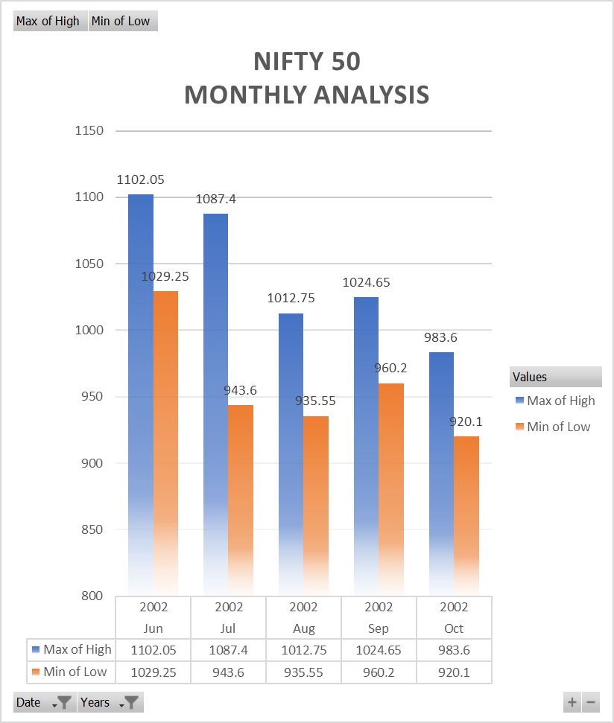

## Nifty 50 Yearly Turnover:

* 1. Introduction: The analysis shows the yearly Turnover of the Nifty 50 from 2000 to 2020
  2. Specific Requirements/Functions and Formulas:

i) Pivot table of the data of Nifty

ii)With the help of data Clustered Bar chart is plotted.

* 1. Analysis Result:
* By this yearly turnover analysis of nifty from 2000 to 2020 we can see that it continuously goes on increasing till 2019 after 2019 there is slightly downward this might be because of Covid-19.
  1. Visualization:

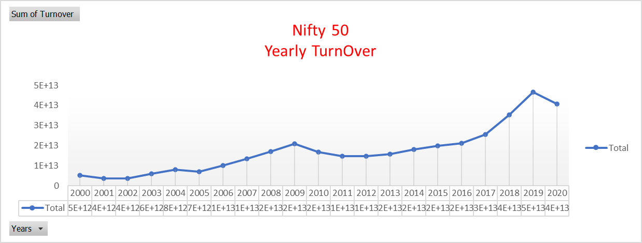

## Nifty 50 Yearly Volume Traded:

* 1. Introduction: The analysis shows the Yearly Volume Traded of the Nifty 50 from 2000 to 2020
  2. Specific Requirements/Functions and Formulas:

i) Pivot table of the data of Nifty

ii)With the help of data Clustered Bar chart is plotted.

* 1. Analysis Result:
* By this yearly volume traded analysis of nifty from 2000 to 2020 we can see that it continuously goes on increasing till 2019 after 2019 there is slightly downward this might be because of Covid-19.
  1. Visualization:

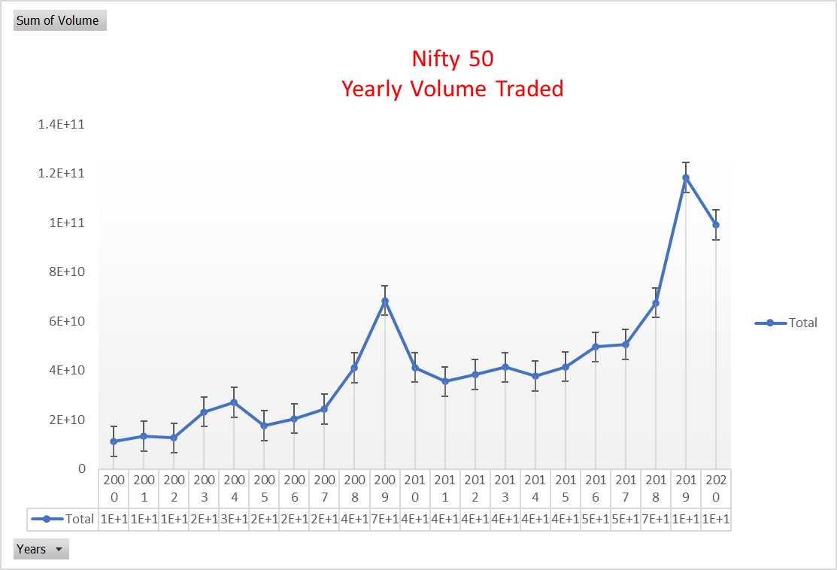

## Nifty 50 % Change Yearly:

* 1. Introduction: This analysis shows the yearly % change of Nifty as compare to the previous year.
  2. Specific Requirements/Functions and Formulas:

i) Pivot table of the data of Nifty 50

ii)With the help of data Clustered Bar chart is plotted.

* 1. Analysis Result:
* By this analysis, we can see that how much % the nifty has been changed in a year as compare to previous year.
* We can see that in year 2000 till 2002 it was in negative and after 2002 it goes on increasing continuously.
  1. Visualization:

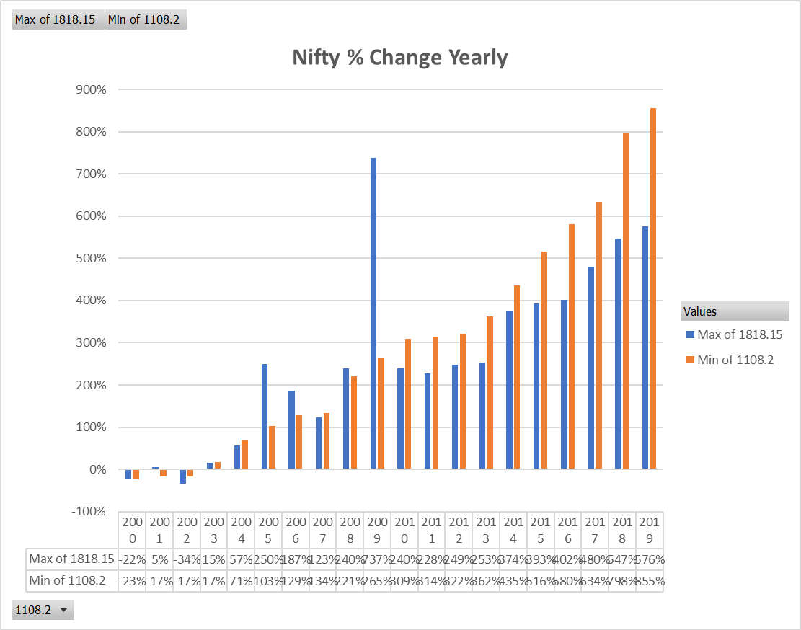

## India-Vix Monthly Analysis:

* 1. Introduction: This India-Vix is one of the Nifty Indices. This analysis shows the monthly changes of India-Vix in the year 2015.
  2. Specific Requirements/Functions and Formulas:

i) Pivot table of the data of India-Vix.

ii)With the help of data Clustered Bar chart is plotted. c)Analysis Results:

* By this monthly analysis of India-Vix we can see that it’s a stable from 2015 Jan till 2015 Dec there is only minor changes.
* But there is a slightly change in the month of Aug and Sep we can see with the help of Tread Line.

d)Visualization:

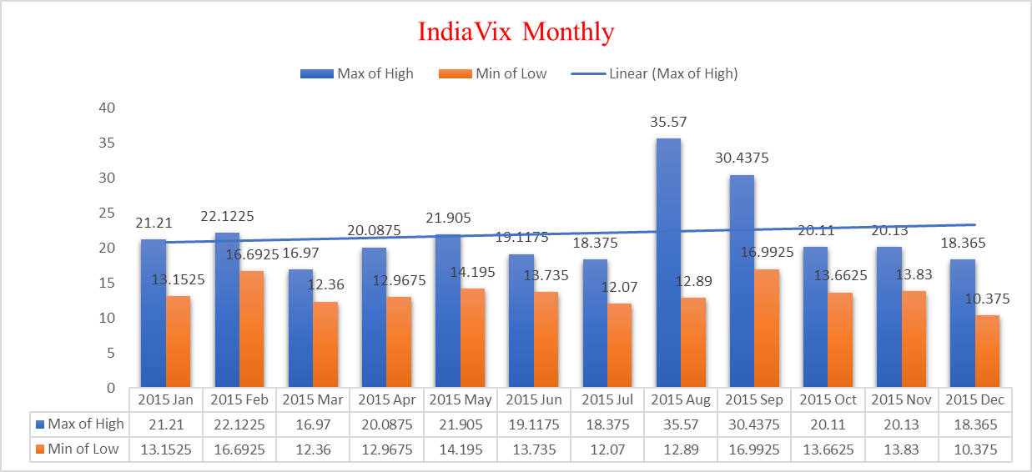

## Dashboard of Analysis:

* 1. Introduction: This dashboard is one-pager that helps managers and business leaders in tracking key and take a decision based on it. It contains charts/tables/views that are backed by data. A dashboard is often called a report, however, not all reports are dashboards
  2. Specific Requirements/Functions and Formulas:

i) Pivot table of the data of Nifty Indices

ii)With the help of data tree map is plotted.

* 1. Analysis Results:

By this dashboard we can see all the charts are together and it becomes easier to analyze the Nifty Indices on single page.

* 1. Visualization:

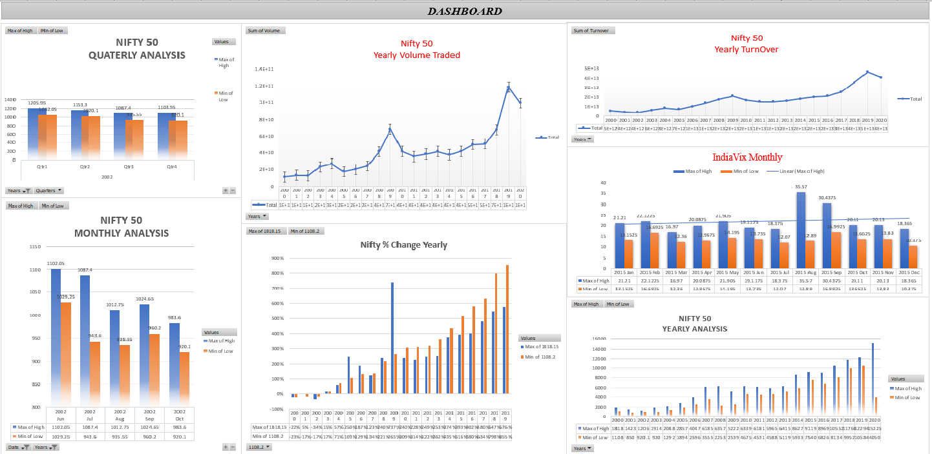

# List of Analysis with Results

* Nifty 50 Yearly, Quarterly, Monthly Analysis from 2000 to 2019
* Nifty 50 Total Volume Traded from 2000 to 2019
* Nifty 50 Total Turnover from 2000 to 2019
* India-Vix Monthly, Quarterly, Yearly Analysis from 2000 to 2019
* Nifty 50 total % change in a year by comparing to previous year and by keeping base year as 2000
* In yearly analysis of Nifty 50 we can see that it was continuously increasing from 2000 till 2019 and suddenly in 2020 it becomes gap down this might be because of COVID-19.
* In Monthly Analysis of India-Vix we can see that in the year 2015 its steady from Jan to Dec only slightly change in the month of Aug and Sep.

# Conclusion

# Based on the observations made in the data and analysing it year by year, month by month I feel like it may have been hit very hard due to the pandemic but it will soon rise above it when the environment gets stabilized.

# In India the sentiments of people towards the stock market plays a huge importance on the graph.

# Let's hope the pandemic period gets over soon.

# References

1. [www.kaggle.com](http://www.kaggle.com/)
2. [www.google.com](http://www.google.com/)
3. [www.stackoverflow.com](http://www.stackoverflow.com/)
4. [www.github.com](http://www.github.com/)

# Bibliography

1. Microsoft Excel 2016 Bible: The Comprehensive Tutorial Resource by John Walkenbach, Wiley
2. Fundamentals of Business Analytics by R.N. Prasad, Seema Acharya, Wiley